Ideation Phase
Define the Problem Statements

Date | 28 February 2026
Team ID | LTVIP2026TMIDS36731
Project Name | Heart Disease Analysis
Maximum Marks | 2 Marks

Customer Problem Statement Template:
Create a problem statement to understand your customer's point of view. The Customer Problem Statement template helps you focus on what matters to create experiences people will love.
A well-articulated customer problem statement allows you and your team to find the ideal solution for the challenges your customers face. Throughout the process, you’ll also be able to empathize with your customers, which helps you better understand how they perceive your product or service.

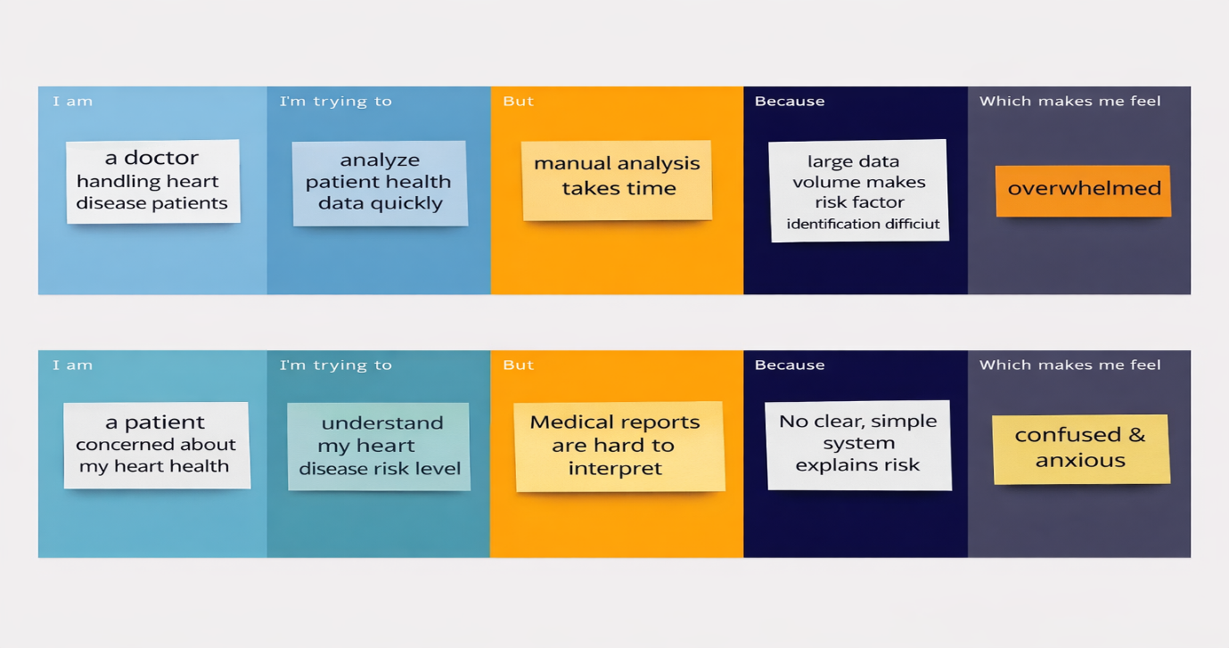
Reference: https://miro.com/templates/customer-problem-statement/

Problem Statement (PS) | I am (Customer) | I’m trying to | But | Because | Which makes me feel
PS-1 | A doctor or healthcare professional handling heart disease patients. | Analyze patient health data quickly to identify heart disease risks early. | Manual analysis of multiple medical parameters takes time and may lead to error | Large volumes of patient data make it difficult to identify important risk factors accurately. | Overwhelmed and concerned about missing early warning signs in patients.
PS-2 | A patient concerned about my heart health. | Understand my risk level and take preventive action early. | Medical reports are complex and difficult for me to interpret. | There is no simple system that clearly explains heart disease risk in an easy way. | Confused and anxious about my health condition.

